1. **PWD :- (Print your current working directory).**

This is the screen shot after executing PWD Command on VM.

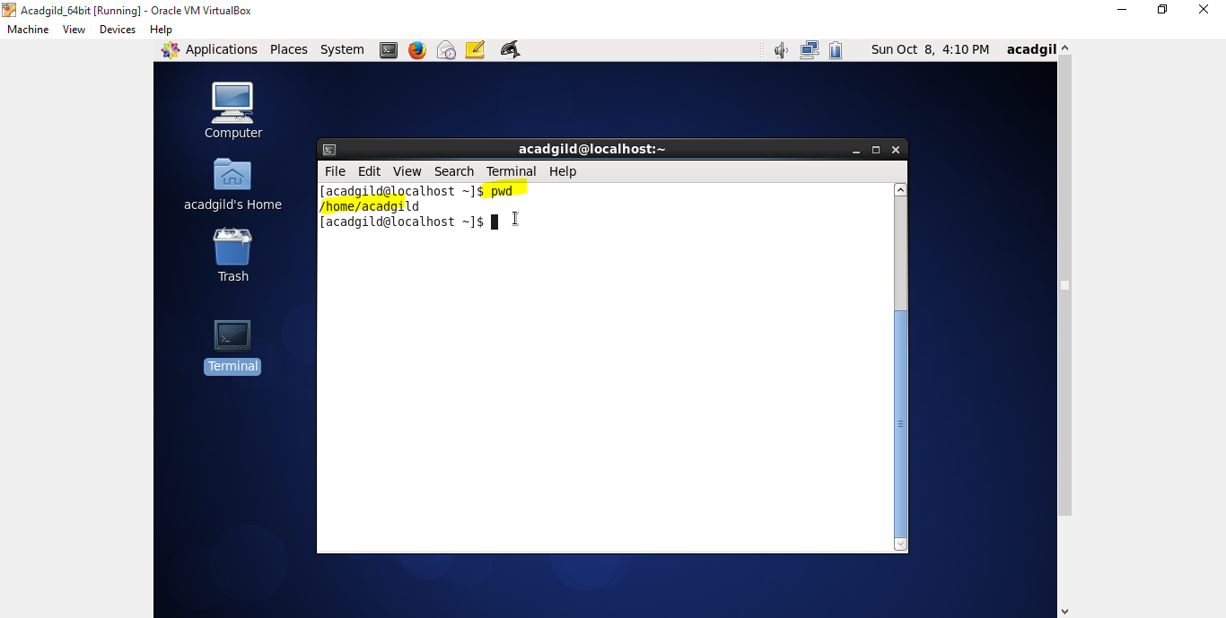

1. **Visual text editor.**

If you want edit existing file then we have to use this command. And below is screen shot for VI.

Below blue color arrow shows that before modification. And rounded with red color after adding some data in existing file.txt

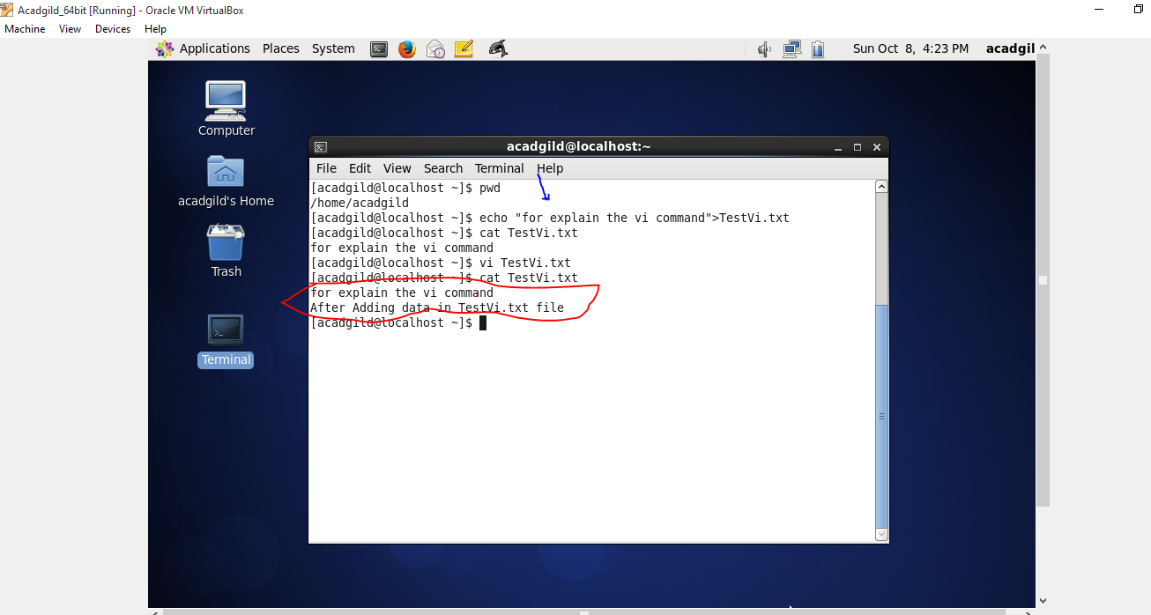

1. **Touch :- (**create, change and modify timestamps of a file**)**

File created by using Touch command.

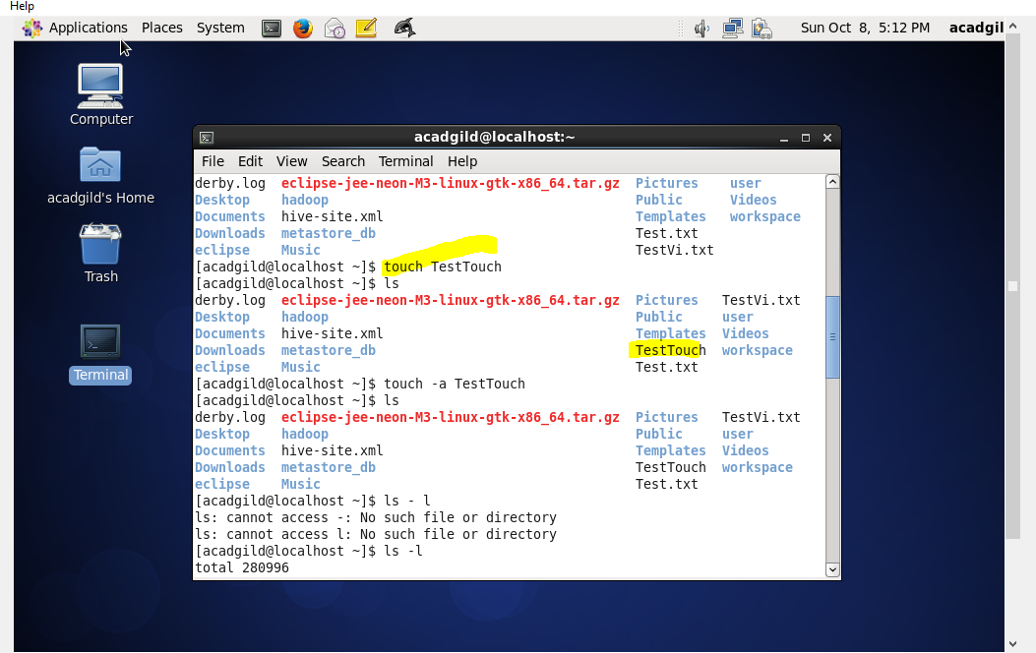

1. **Mkdir :- (Make Directory)**

After Making Directory.  
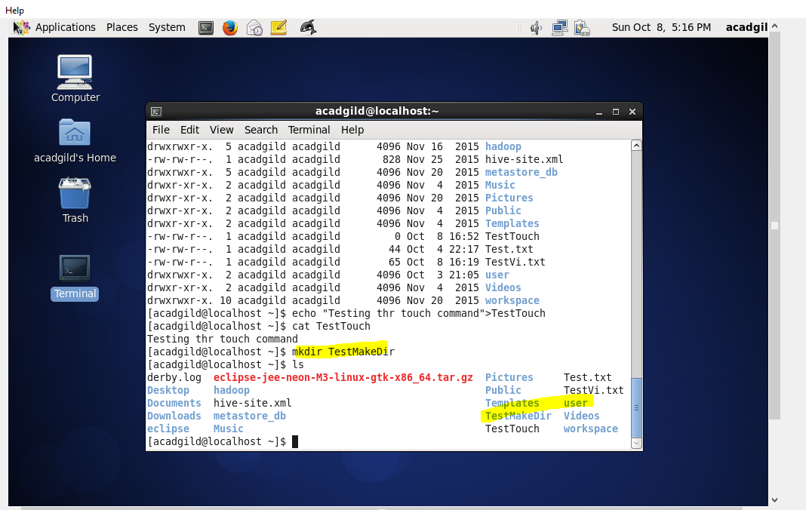

1. **Rm :- (Remove the directory and file)**

**After Removing the File.**

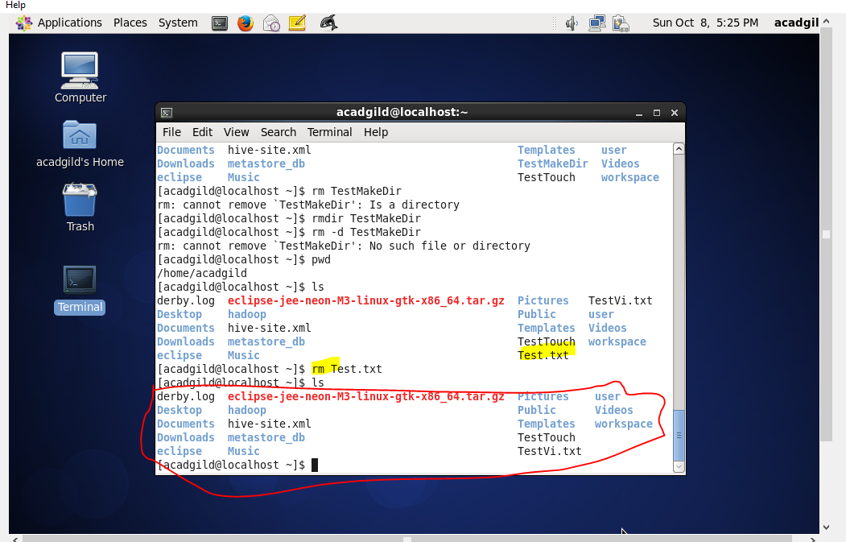

1. **Ls (Will show the number of files and directories in present directory).**

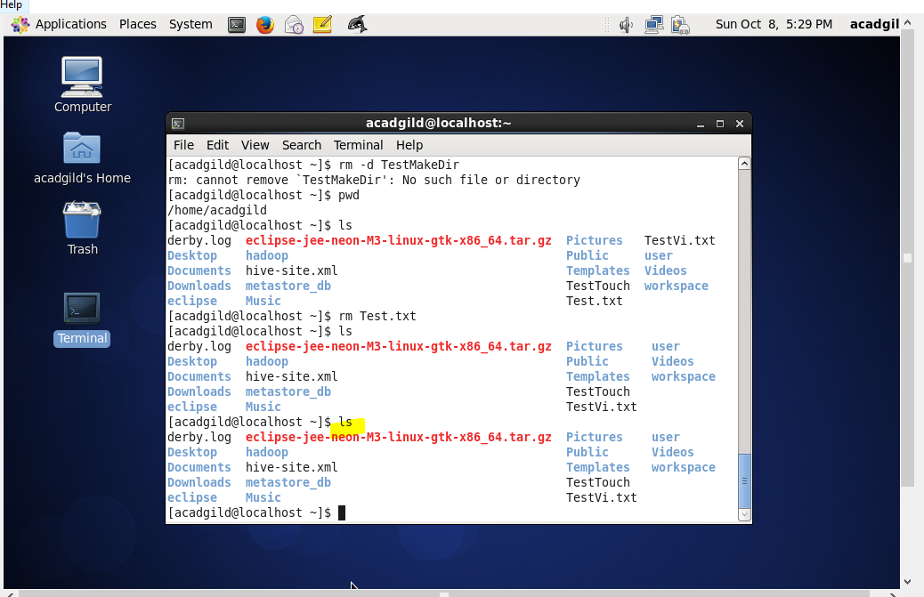

1. **Echo and Cat :- (Adding data in particular file).**

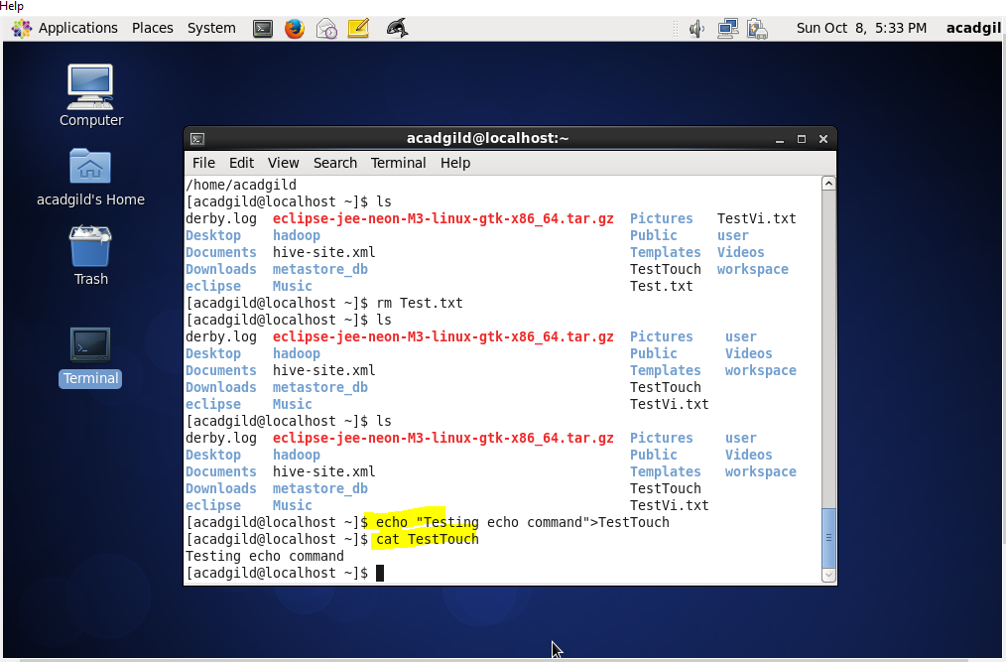

**10. CD :- Change Directory**

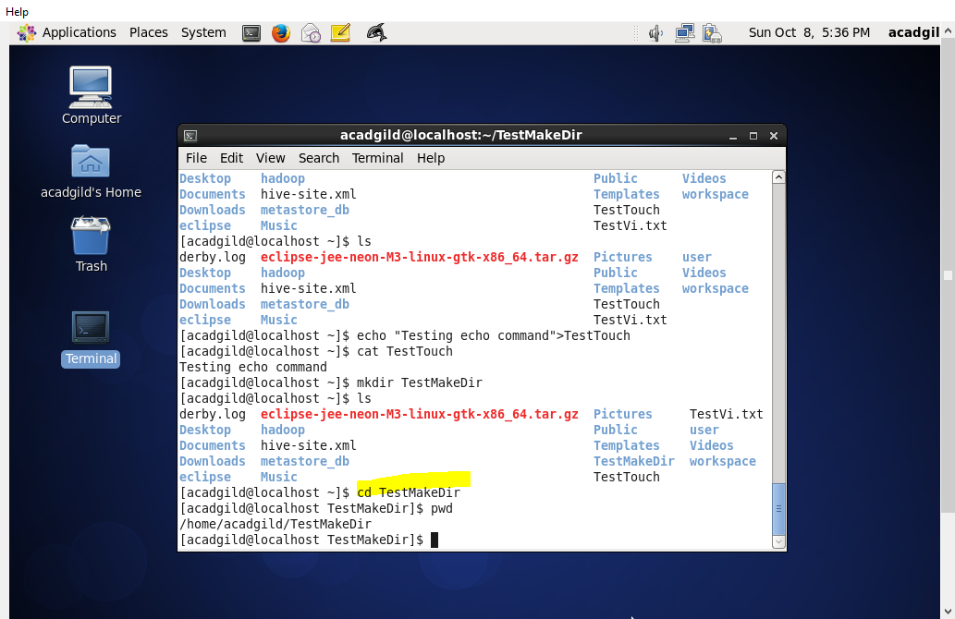

**11. mv :- Move the files from one directory to another directory .**

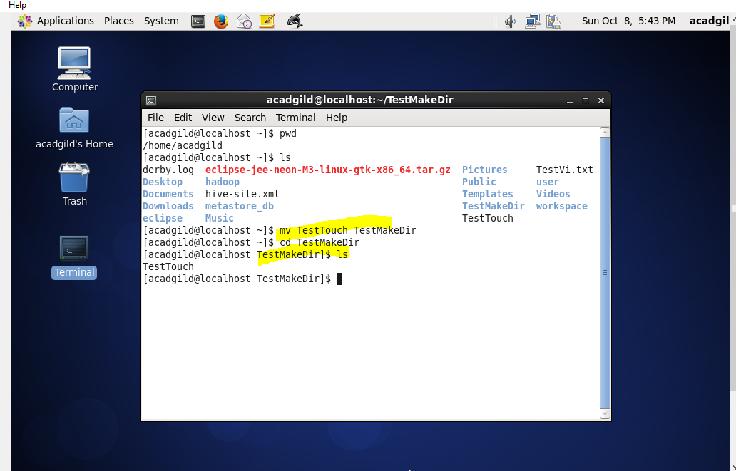

**12. who and Which :- (Display who is on the system).**

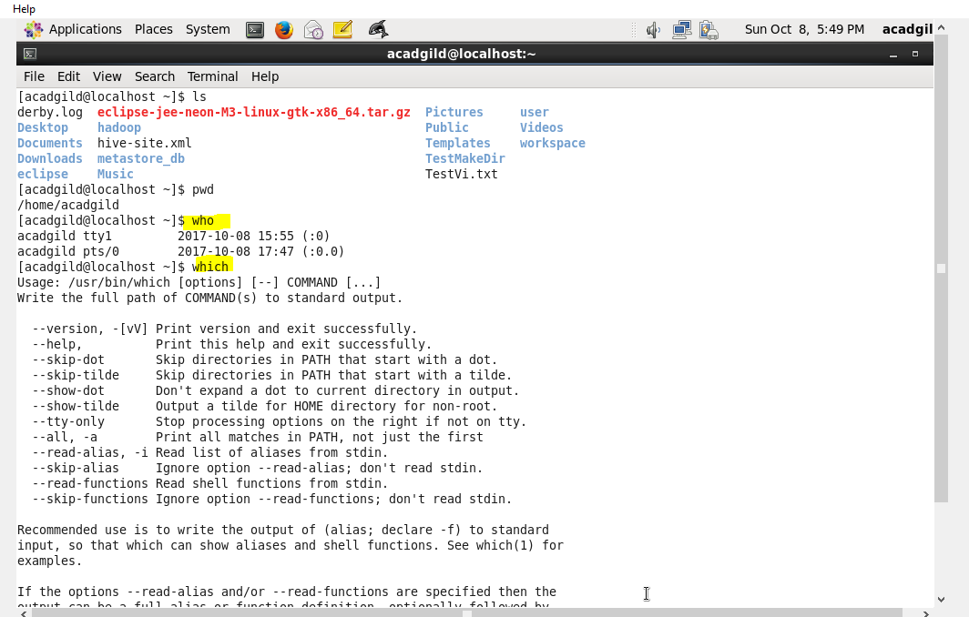

**14. cal and date :- (Displays the calendar).**

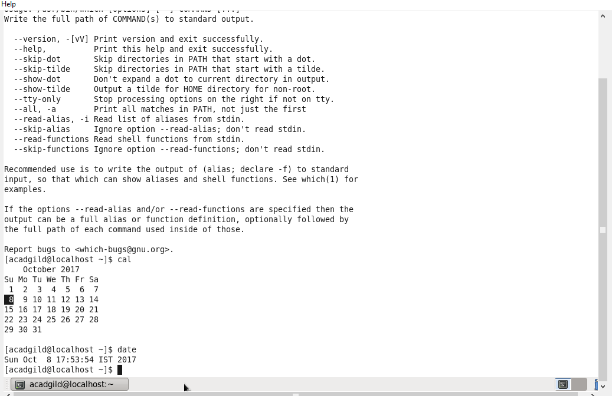

**15.CP :- copying the file and directory.**

